First Evidence Plate Analyst’s Workstation User Guide

Software Version 3.0.1
18 September, 2009

Contents

System Overview 2
Search Tool 3
Time Range 3
Operation 5
Dumping All Items Found 5
Searching for a Plate Number 5
Displaying the Image Associated with a Search Result 6
Export An Image or Image List 6
Exporting a GPS location 6
Playing a Video Clip 7
Batch Mode Processing 8
Edit Mode Processing 9
Import Images 10

System Overview

The Plate Surveillance System 3.0 consists of the following applications:
- FE Plate Analysts Workstation
  - Search tool allowing the search of stored images and video playback, and image export
  - Batch processing video files and jpeg images
  - Edit mode processing of jpeg images allowing the editing of results and pushing those results to the database
  - Importing stored image data from a field drive to a central repository

Search Tool
Smart Search allows you to find plates that were detected whether or not you know the correct or full plate number, even if the plate was not read correctly by the PSS. It uses a First Evidence invented algorithm for finding best matches – efficiently handling missing letters or wrong letters.

The Smart Search control is easy to use and intuitive. It allows you to export a single result or a list of results.

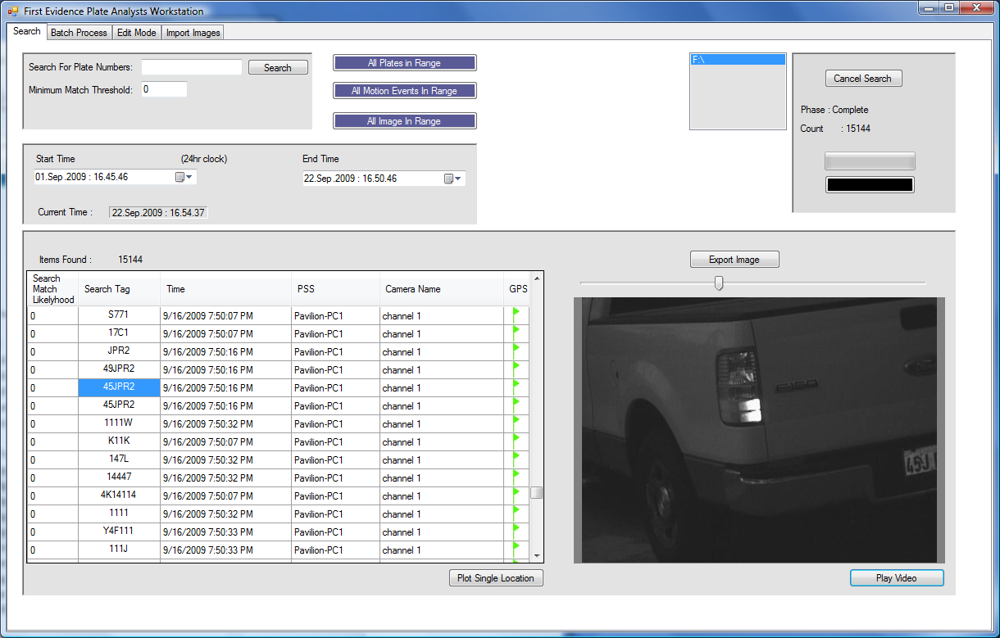

Time Range
All searches are limited be the start time and end time settings. All times are in Universal Time Coordinated (UTC/GMT). The current time clock gives the current time in UTC time for a quick refence.

All Plates In Range button – this button will cause a dump of all plates found in the time range.
All Motion Events In Rage button – this button will cause a dump of all motion events recorded in the time range.
All Images In Range button – this button will dump all images in the time range. If there are over 1000 images, the dump will report an error. In this case, narrow the time range down and re-try.
Plate Search – enter a full or partial plate number to search on.

Enter the text you are searching for
The current storage location being searched
Minimum match threshold

Dump Range Buttons

GPS data available flag
Click the image to get the zoom tool. Click again to go back to normal view.

Operation

Dumping All Items Found

You can create a dump of all plates found between a start time and end time, using the following procedure.

- Set the Start Time.
- Set the End Time.
- Click the All Plates in Range, All Motion Events, or All Images in Range button.

Notes:
- GPS data may not be available if the image source was not configured to use GPS.
- Depending on the vehicle traffic volume of your system, a dump can be extremely large. Consider narrowing the start-end time range.
- If your intent is to extract the data of the entire storage area, consider using Windows Explorer to copy the storage directory to a backup media or other directory. This is one of the benefits of our open architecture design.

Searching for a Plate Number

Using the provided demo file and watch list, experiment with using search numbers that are not exact matches to the number you are searching for. Try omitting numbers, and typing some incorrect characters. Notice the match result likelihood in each case.

- Enter the number in the “Search For Plate Numbers” box.
- Enter the minimum match threshold
- Set the start time
- Set the end time
- Click Search

Notes:
- If no results are found, consider lowering the match threshold.
- If no results are found, consider changing the time range.
- If you are evaluating the system (not in production mode) the time in which plates entered the storage area can be difficult to determine. We suggest setting the start time to a very long time in the past (say one year ago) and the end time to the future. Then follow the directions above for Dumping the Entire Storage Contents. Then you will see any plates that exist in the storage area and also will be able to inspect the time stamps.

Displaying the Image Associated with a Search Result

Click on the text on any row in the results table. Be sure to click on the text and not on white space or else the click will not be registered.

Note: the image with the actual plate number may be one or two frames before or after the indicated image. Use the video player to see seconds before and seconds after the selected image.

Export An Image or Image List

Once you have displayed an image, you can export that image along with a text file with the image details. All of the details, detected number, time observed, and camera source name, are available without First Evidence software: The file name of the image contains the detected number and the time stamp. The camera source name is embedded in the jpeg image file itself in the metadata field. In this way, each jpeg image file becomes a stand-alone item of evidence.

However, since it requires a special piece of software to view the jpeg meta data, all of this information is extracted and stored in a text file when you export an image.

When you click on “Export List” or “Export Image” you will be prompted to select a directory and name a text file. This text file will contain:

match likelihood, scanned number, time, camera name, image path

In the case of exporting an image, there will be only one line in the file, and in the case of export list, there will be one line for every result in the search results table.

In the same directory you choose to save this text file, the application will create a directory called IMAGES. This directory will contain a copy of each image associated with the extracted data.

Exporting a GPS location

To plot a single location on Google maps (requires an internet connection), select a plate and the click the button “Plot Single Location.

To export a list of locations (such as all the locations that particular plate was observed), first search for the plate, and narrow the search results to less than 200. Then click the button “Export Location List”. You will be prompted to select a file name. The file will contain a list of coordinates that can be imported into commercial GPS mapping software such as Delorme XMap 6 Professional.

Playing a Video Clip

Once a search result has been selected in the search results table, click on Play Video. This will bring up a video player and pre-load images for 5 seconds before and 5 seconds after the indicated image. You can then adjust the pre-post time range and re-load the images.
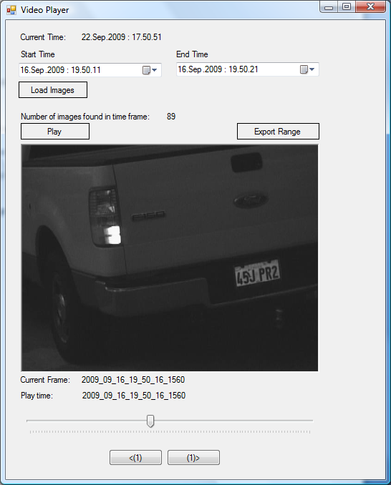
Use the Load Images button to re-load after adjusting the start and end time range
Play one frame at a time, forward or backwards.
Adjust the time range using the start/end time (time are UTC).
Export a range of images.
Click the image to save the image to a file.
Control the play position manually.

Batch Mode Processing
Batch Mode processing allows the user to LPR process a directory of video files, a directory of jpeg images, or a specific video file (to process a single jpeg image use the Edit mode processing tab).
The LPR results will be stored in the central repository (if one is attached). The source name in the database will be the file name of the source video/image file.
The user can choose to have images stored in either the repository or a user selected directory. Storing to a directory is a method for extracting all jpegs from a video file. Also, the user can specify to store images only if motion is detected or only if plates are detected. This helps reduce the video clip down to the images that contain useful information.
Parallel processing windows are started, one for each core in the computer. Eight cores are supported.
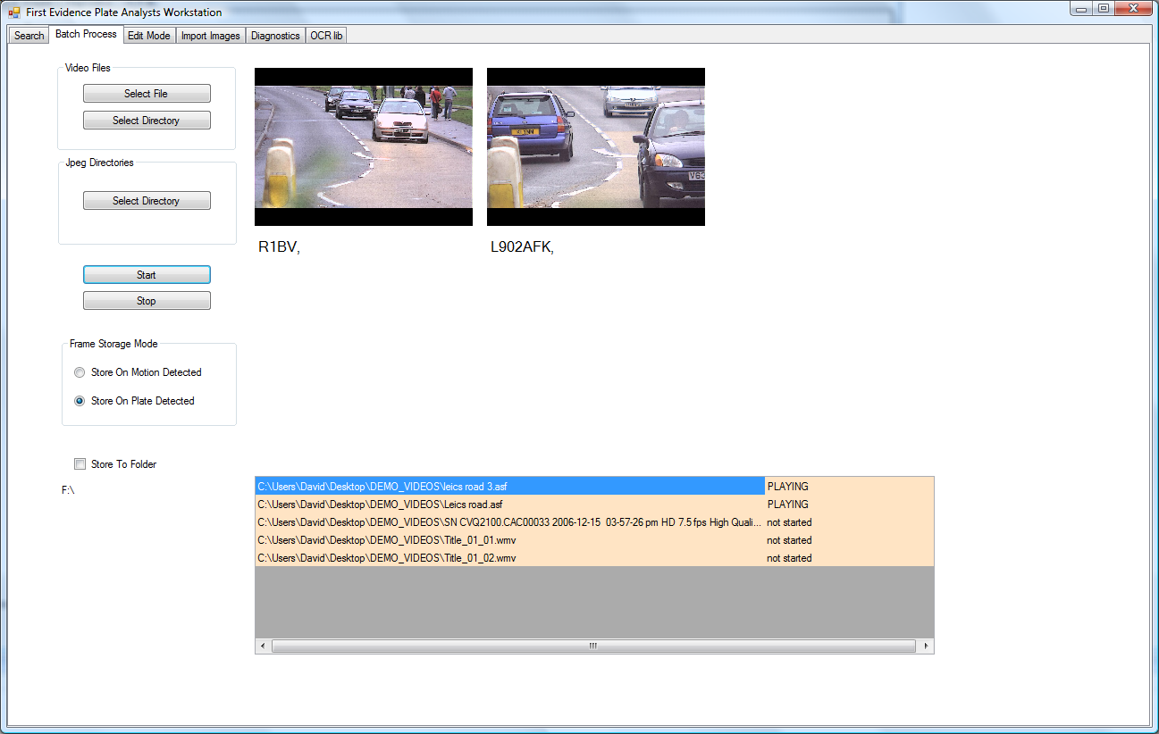
Select either a single video file or a directory of files.

Select either a directory of jpeg images.
Start and Stop batch processing.

Select to store extracted jpeg frames only on Motion or only on Plate detected.

Check box to select a user specified folder to store extracted jpeg images. Checking the box will bring up a folder browser.
Process status listing of batch files.

Once images have been processed, the Search tool can be used to find the results (and extracted images) in the database.

Edit Mode Processing
Edit Mode processing allows the user to select individual jpeg images, run them through LPR processing, then edit the results.
Load File Button – select an individual jpeg file for processing.
Load Directory – select a directory of jpeg files for processing. Use the ‘<’ and ‘>’ buttons to move through the images. Or press the Show Thumbnails button to browse the images and select one for processing.
Check the “Process when Selected” check box to process each image as the images are selected with the left/right arrow buttons. This can slow down browsing as each image is processed and all the sub-images are extracted and loaded into the editor.
Once an image has been processed, if a plate is detected and read, the results are loaded into the plate edit tab. The user can change the individual letters before pressing the Store Results button. The Store Results button sends the LPR result to the database (assume a central repository is attached).
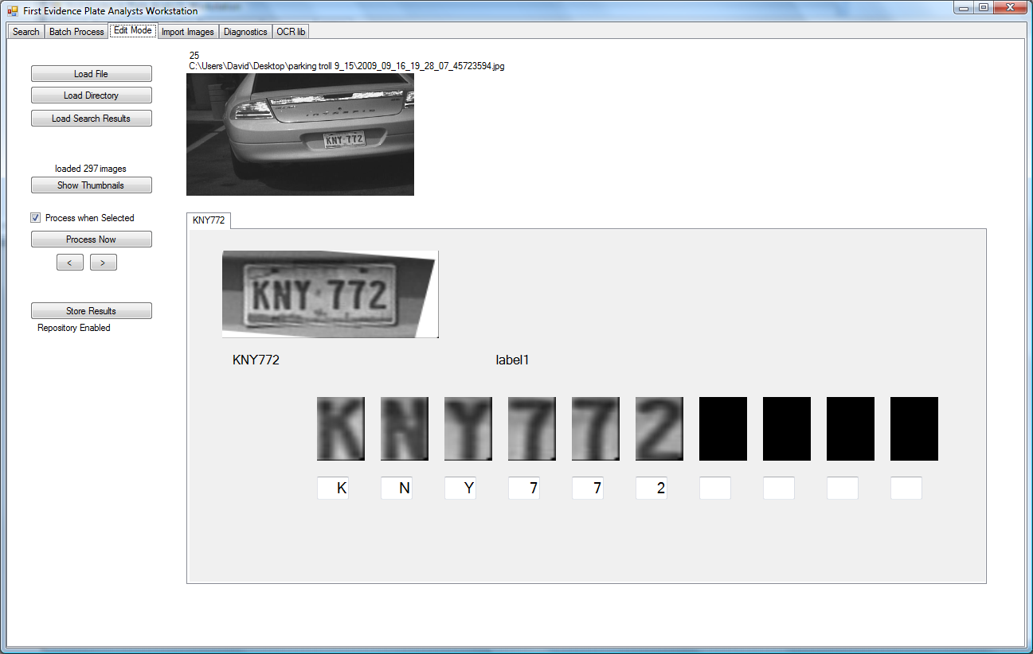

User can make corrections here.

Import Images

The Import Images tab allows the user to import images from a field drive to a central repository drive. These drives are automatically detected by the application. There should be only one central repository and only one field drive attached at a time.
A central repository is a drive (such as F:\) that has a specific file in its root directory:
F:\firstevidencedrive.txt, where the contents of this file is the single word “central”.
A field drive is a drive which contains the same file but the file is empty (such as H:\firstevidencedrive.txt).
If the Current Central Repository or Detected Field Drive boxes are empty, there is a problem with detecting the drives. Using Windows Explorer, ensure that the drives are attached and contain the correct key file (firstevidencedrive.txt). Drives may be attached either as physically (as in the case of USB or internally mounted drives) or mounted via a Windows shared drive (as long as the key file appears in the root directory).
The once the user clicks on the Start button, all images, and LPR/Motoin event data will be merged into the central repository file structure (based on time and PSS system name). The source files are deleted as they are moved.
